

EXOR

Maintenance Manager Release Notes

v4.6.1.0

Document Version History
Version | Owner | Source | Date | Description
1.0.0 | Chris Baugh | Author | 14 Jan 2013 | Initial Draft
For review: |  |  |  | For approval:

Table of Contents
1. About this Document 2
1.1 Authors 2
1.2 Document Summary 2
1.3 Reference documents 2
1.4 Distribution 2
2. Introduction 2
3. Pre-Requisites 2
4. Functional Changes 3
4.1 Priorities by Admin Unit 3
4.1.1 MAI3812 - Defect Priorities 3
4.1.2 MAI1325 - Enquiry/Defect Priorities 5
4.1.3 MAI3813 – Maintain Automatic Defect Prioritisation 6
4.1.4 MAI3807 – Locator Create Defects 6
4.1.5 MAI3808 – Inspections 7
4.1.6 MAI3818 – Work Order Automation Rules 7
4.1.7 Inspection Loader 7
5. Fixes, Enhancements and Changes at 4.6.1.0 7

About this Document

Authors
- Chris Baugh: Senior Developer

Document Summary
This document provides a description of the changes in this release and information about how these changes may impact on an installation.

Reference documents

Distribution
Bentley/Exor Customers, Partners and Colleagues

Introduction
This document defines the changes made to the Maintenance Manager product at release 4.6.1.0 plus a list of all logs fixed in this release.
Unlike the “Maintenance Manager Installation/Upgrade Guide”, this document is specifically targeted at the Maintenance Manager end user. Therefore, if the recipient of this document is an IT person please ensure that it is forwarded on to the relevant end user(s).
This document does not comprehensively describe the functionality of the product, or act as a User Guide.
Please note that any data shown in example screenshots does not represent any Customer’s live data; it is test data set up by Bentley.
After reading through this document, should you have any further Maintenance Manager training or Consultancy requirements then please contact your Bentley account manager.

Pre-Requisites
This release of Maintenance Manager should only be applied after Network Manager v4.6.0.0 fix 2 has been applied.

Functional Changes
This section outlines the functional changes made at 4.6.1.0

Priorities by Admin Unit
Maintenance Manager has been modified to allow Defect Priorities to be defined by Admin Unit, providing the flexibility to define a separate set of rules for each Admin Unit, if required.

As a default, upgrade scripts have been provided to ensure existing rules will be defined at the top level Admin Unit, allowing for business as usual.

Addition of the Admin Unit to Defect Priorities will provide the ability for an Admin Unit to define a Target Response Time of their choosing to a Maintenance Activity, Defect Priority, Repair Type combination, overriding the details set at a higher level in the Admin Unit hierarchy.

MAI3812 - Defect Priorities
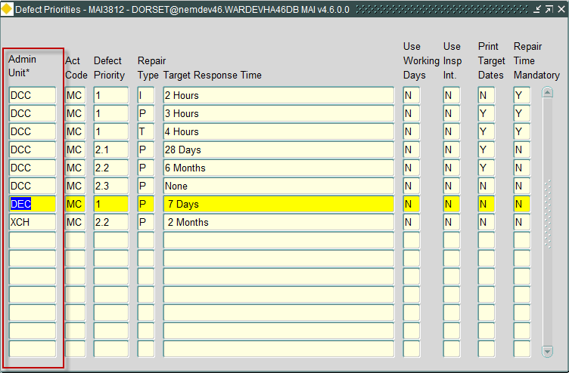

The Defect Priorities form has been modified to include Admin Unit allowing for Target Response times to be defined by Admin Unit. The following rules apply, for any user accessing this form
- Only rules to which the User has been granted Admin Unit privileges will be accessible by the User.
- Any rules defined for an Admin Unit will override those defined at a higher level in the Admin Unit hierarchy.

Using the details shown in the Defects Priority form shown above, as an example. if the Admin Unit hierarchy is as follows:

For Admin Unit DCC, the following set of Priorities will apply for Activity Code ‘MC’:

Defect Priority | Repair Type | Target Response Time
1 | I | 2 Hours
1 | P | 3 Hours
1 | T | 4 Hours
2.1 | P | 28 Days
2.2 | P | 6 Months
2.3 | P | None

For Admin Unit DEC, the following set of Priorities will apply for Activity Code ‘MC’:

Defect Priority | Repair Type | Target Response Time
1 | I | 2 Hours
1 | P | 7 Days
1 | T | 4 Hours
2.1 | P | 28 Days
2.2 | P | 6 Months
2.3 | P | None

For Admin Unit XCH, the following set of Priorities will apply for Activity Code ‘MC’:

Defect Priority | Repair Type | Target Response Time
1 | I | 2 Hours
1 | P | 7 Days
1 | T | 4 Hours
2.1 | P | 28 Days
2.2 | P | 2 Months
2.3 | P | None
Note: Where values defined for an Admin Unit override those at a higher level, these have been highlighted

MAI1325 - Enquiry/Defect Priorities
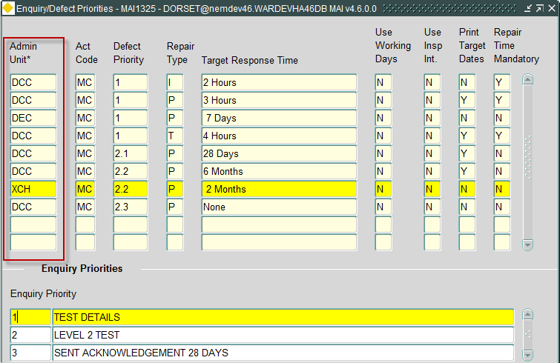
The Enquiry/Defect Priorities form has been modified to include the Admin Unit associated with the Defect Priority. The following rules apply, for any user accessing this form
- Only Rules to which the User has been granted Admin Unit privileges will be accessible by the User.

Specification of Enquiry Priority, for the selected Defect Priority, will take account of the selected Defect Priorities Admin Unit ensuring that Enquiry Priorities are correct for the currently selected Admin Unit.

MAI3813 – Maintain Automatic Defect Prioritisation
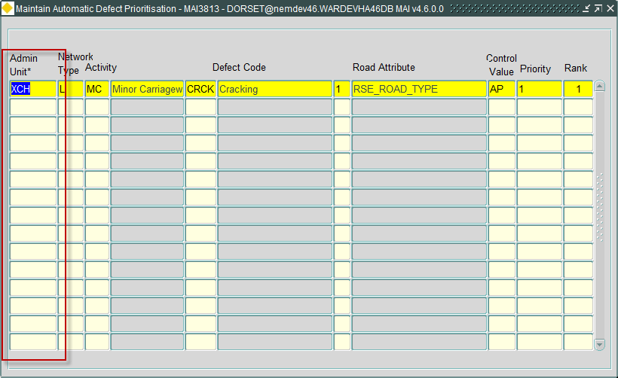
The Maintain Automatic Defect Prioritisation form (MAI3813) has been modified to allow for Automatic Defect Priorities to be defined by Admin Unit. The following rules apply, for any user accessing this form
- Only Rules to which the User has been granted Admin Unit privileges will be accessible by the User.

MAI3807 – Locator Create Defects
Locator Create Defects form (MAI3807) has been modified to accommodate the addition of the Admin Unit to Defect Priorities as follows:
- Valid priorities will be based on the list of Defect Priorities defined in the Defect Priorities form (MAI3812) for the Activity, and where the Admin Unit is within the Admin Unit hierarchy of the associated network
- Allowed repair types, defined in the Defect Priorities form (MAI3812), for a defect, are based on the Activity and the Admin Unit of the associated Network.
- The calculation of the Repair due date will take the Admin Unit of the associated Network into account, when identifying the appropriate Defect Priorities values to be used in the calculation
- If Automatic Defect Prioritisation is being used (defined by product option DEFAUTOPRI), the Admin Unit of the Network assigned to the Defect, along with the Defect Activity, will be used to identify appropriate details, defined in Maintain Automatic Defect Prioritisation form (MAI3813)

MAI3808 – Inspections
Inspections form (MAI3808) has been modified to accommodate the addition of the Admin Unit to Defect Priorities as follows:
- Determination of whether Repair Time specification is mandatory, will be based on the associated Defects Priority entry, defined in the Defect Priorities form (MAI3812) for the Activity, and where the Admin Unit is within the Admin Unit hierarchy of the associated network
- Allowed repair types, defined in the Defect Priorities form (MAI3812), for a defect, are based on the Activity and the Admin Unit of the associated Network.
- The calculation of the Repair due date will take the Admin Unit of the associated Network into account, when identifying the appropriate Defect Priorities values to be used in the calculation
- If Automatic Defect Prioritisation is being used (defined by product option DEFAUTOPRI), the Admin Unit of the Network assigned to the Defect, along with the Defect Activity, will be used to identify appropriate details, defined in Maintain Automatic Defect Prioritisation form (MAI3813)

MAI3818 – Work Order Automation Rules
Work Order Automation Rules form (MAI3818) has been modified to accommodate the addition of the Admin Unit to Defect Priorities as follows:
- Allowed repair types, defined in the Defect Priorities form (MAI3812), for a defect, are based on the Activity and the Admin Unit of the associated Network.

Inspection Loader
The Inspection loader has been modified to accommodate the addition of the Admin Unit to Defect Priorities as follows:
- Allowed repair types, defined in the Defect Priorities form (MAI3812), for a defect, are based on the Defect Activity and the Admin Unit of the associated Network.
- Validation of the Defect Priority will ensure that the value is valid for the Defect Activity and the Admin Unit of the associated Network.
- The calculation of the Repair due date will take the Admin Unit of the associated Network into account, when identifying the appropriate Defect Priorities values to be used in the calculation
- The Admin Unit of the associated Network will be used in the identification of the rules defined in Work Order Automation Rules form (MAI3818) to determine if Work Orders should be automatically created for the details being processed

Fixes, Enhancements and Changes at 4.6.1.0
The following are a list of internal task identifiers with associated ECDM fault logs/Bentley help ticket numbers (where appropriate) that have led to changes in the 4.6.1.0 release.
Internal Task ID | Issue | Support Log(s)
0112323 | When creating a Works Order from Locator (NM0572) using `Raise Small Scheme Work Order’ the initial status of the Work Order is automatically set to INSTRUCTED. The form has been modified to ensure that all WO Line statuses, and the associated Work Order status are set to the initial status (Usually DRAFT status).

